Lab:

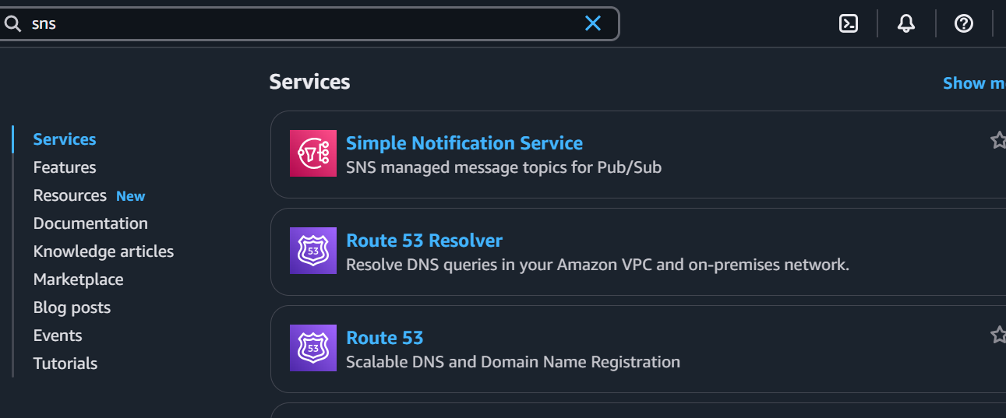

Go to Create topic and provide a name🡪Click on next step

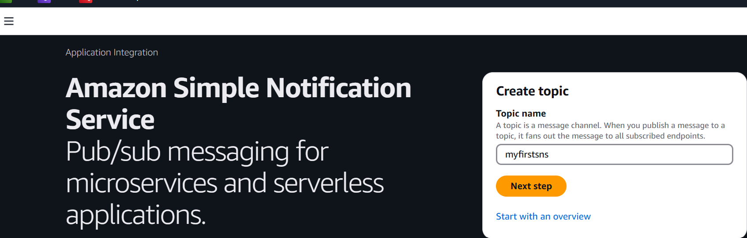

We’re not going to apply any custom changes so will keep as default & click on Create Topic.

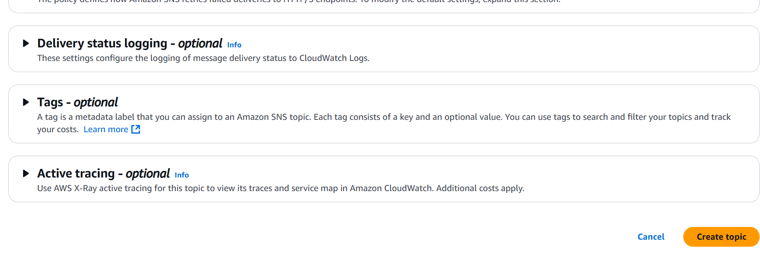

Now as we see in below picture, there is no Subscription in Topic so we will create subscription, click in Create Subscription.

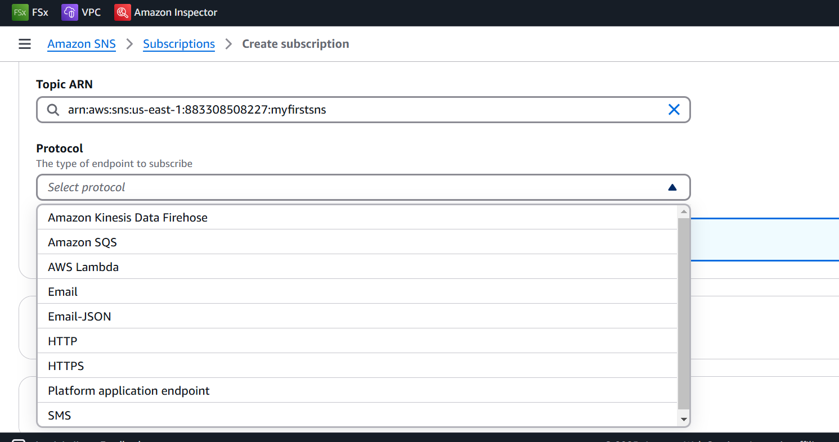

Select email and provide your gmail id

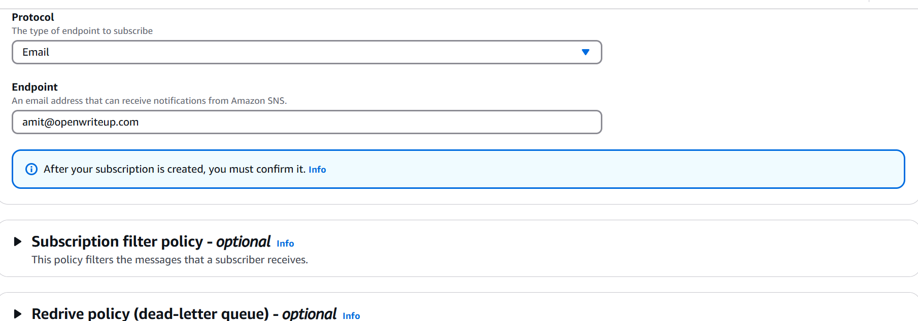

Confirm the subscription

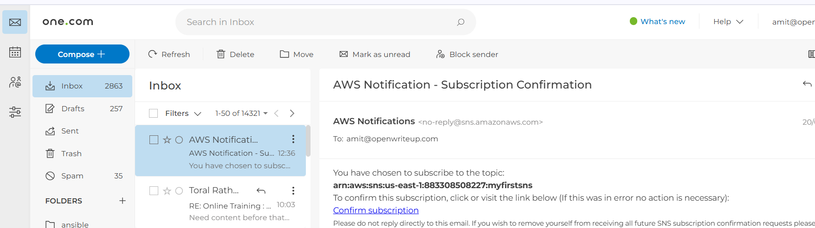

Click on publish message

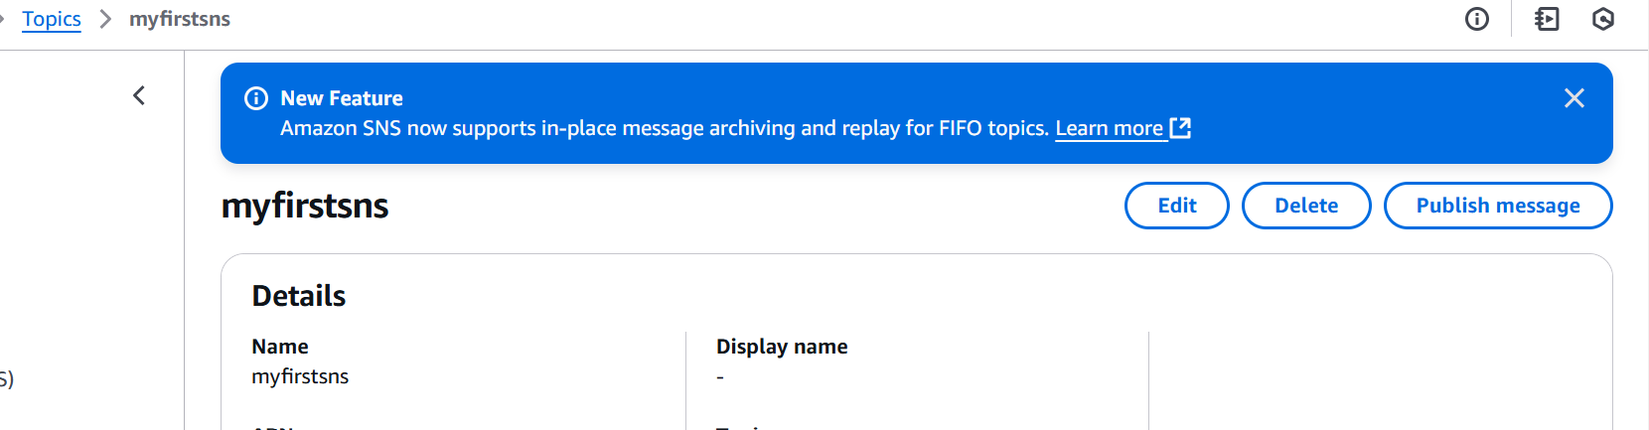

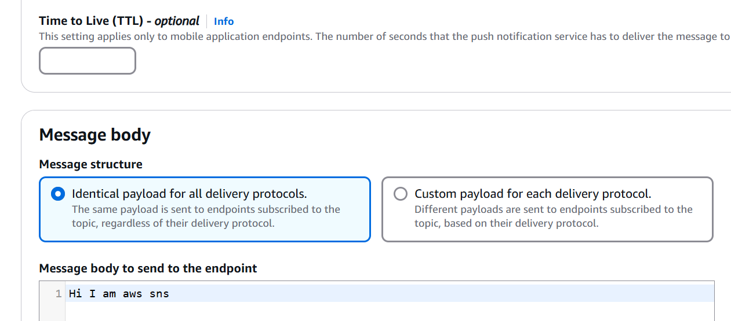

Create a sqs queue and subscribe for sns

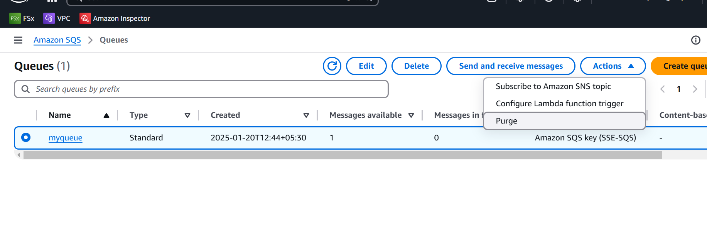

Check poll for messges

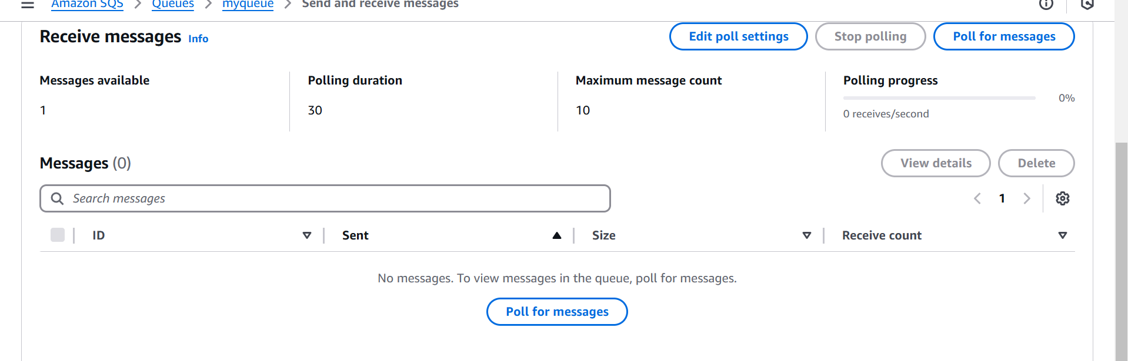

Delete all the aws resources